Real-Time Banknote Authentication Using Computer Vision and Unique Fluorescent Sig- natures on an Embedded System

Talla Ashwini Kumari Assistant Professor
Sreyas Institute of Engineering and Technology,
Hyderabad, India ashwani.talla@sreyas.ac.in
Krishna Reddy Nanditha
UG Scholar
Electronics and Communication Engineering
Sreyas Institute of Engineering and Technology,
Hyderabad, India reddynandu2005@gmail.com

Shaik Abrar Ali
UG Scholar
Electronics and Communication
Engineering
Sreyas Institute of Engineering and Technology,
Hyderabad, India shaikabrarali66@gmail.com
Chamanthula Abhilash
UG Scholar
Electronics and Communication Engineering
Sreyas Institute of Engineering and Technology,
Hyderabad, India abhilashch036@gmail.com

Abstract—Counterfeiting currency remains a critical economic threat, particularly in developing economies where cash circulation remains high de- spite digital trends. While central banks employ so- phisticated forensic machinery to detect forged notes based on stochastic security features, such as random fiber distribution, these systems are financially and logistically inaccessible for retail merchants. This study introduces a low-cost, embedded framework for authenticating Indian Currency (INR) in real-time. We engineered the prototype using a Raspberry Pi 4 Model B, coupled with a high-definition optical sensor and a 365 nm UV excitation module. Rather than depending on simple fluorescence detection like tradi- tional methods, our approach implements a dual- stage hybrid algorithm. First, it validates the material composition by quantifying fluorescent intensity through HSV thresholding; second, it verifies the note's spatial geometry and micro-printing using ORB (Oriented FAST and Rotated BRIEF) feature matching. Users receive an instant binary verdict via an integrated LCD screen. Performance testing vali- dates that by isolating deterministic fluorescent markers, the system reliably distinguishes authentic currency from forgeries, making it a viable and scal- able solution for point-of-sale security.
Index Terms—Banknote Authentication, Com- puter Vision, Embedded Systems, Image Processing, ORB, Raspberry Pi, UV Fluorescence.
- INTRODUCTION

The persistence of physical currency in the global economy has sustained the profitability of counterfeiting operations. According to recent data, billions of banknotes remain in circulation, necessi- tating robust verification mechanisms at the point of sale [1]. To combat this, central banks incorpo- rate increasingly complex security features into banknotes, including watermarks, holograms, secu- rity threads, and fluorescent fibers embedded in the paper pulp. While the unique fluorescent properties of random fibers allow for the forensic identifica- tion of individual banknotes—essentially creating a unique fingerprint for every piece of paper— verifying these stochastic features requires high- precision laboratory equipment and significant computational power [2]. This creates a technolog- ical gap: Central Banks possess the tools to track individual notes, but local shopkeepers rely on manual inspection or rudimentary UV lamps, which are easily fooled by high-quality photocop- ies using commercial fluorescent inks. This paper proposes a bridge to this gap by developing a commercial-grade verification system. Instead of focusing on the microscopic randomness of fibers, which requires matching exact coordinates against a terabyte-scale database, our system focuses on the Deterministic Fluorescent Patterns of the bank- note class. By leveraging Computer Vision on an

embedded platform, we automate the detection of two critical validity indicators:
- Spectral Fidelity: Analyzing the specific Hue, Saturation, and Value (HSV) of the fluorescent response to reject bleached paper or incorrect inks.
- Spatial Analysis: We deploy ORB feature matching to assess the sharpness of critical regions, including bleed lines and denom- ination text; notes usually fail here be- cause their print edges are blurry.

The final prototype packages this logic into a compact box, which simply shows a "Pass" or "Fail" message on the LCD.

- RELATED WORK

The domain of banknote authentication has evolved from manual inspection to automated sig- nal processing. Existing literature classifies verifi- cation techniques into three primary categories: physical property analysis, visible light image pro- cessing, and fluorescence analysis.

- Fluorescence and Fiber Analysis

Ferrero and Montrucchio [2] mapped the sto- chastic scatter of fluorescent fibers to fingerprint individual banknotes. Their algorithm reads the exact (x, y) coordinates and fiber orientations to compile a cryptographic hash. This unique digital signature yields a 100% theoretical classification accuracy and fault tolerance, rendering the notes mathematically immune to cloning. The inherent trade-off is hardware dependence. Running this database synchronization requires high-fidelity laboratory scanners, putting it entirely out of reach for standard retail environments.

Our architecture shifts the focus from individual serial number Identification to broader denomina- tion Classification. The standalone system process- es everything offline. It measures the total UV emission and checks static geometric shapes—such as the floral motif on the ₹500 bill—rather than tracking random fibers. Testing against both circu- lating and counterfeit currency proves this hard- ware-level validation achieves a 96.5% cumulative accuracy.

- Feature Extraction Algorithms

Scale-Invariant Feature Transform (SIFT) and Speeded-Up Robust Features (SURF) demand mas- sive processing power and carry strict patent re-
strictions. We bypass these bottlenecks using ORB (Oriented FAST and Rotated BRIEF) [3]. As Ru- blee et al. proved, ORB mirrors the matching accu- racy of SIFT but executes two orders of magnitude faster [3]. The algorithm achieves rotational invari- ance by tracking local intensity centroids. Because these binary descriptors are so compact, the com- putational load stays low enough for the Raspberry Pi's ARM Cortex-A72 to run the spatial verification pipeline with negligible latency.

- Hardware Implementations

High-speed banking sorters depend on Field- Programmable Gate Arrays (FPGAs) to execute intensive algorithms. Conversely, basic photodi- odes in low-cost testers fail against standard paper treated with Optical Brightening Agents (OBAs). Bridging this gap, our Single Board Computer (SBC) architecture executes OpenCV [4] on Linux. While foundational scale-invariant algorithms [5] achieve up to 99% object recognition accuracy at the expense of severe processing latency, our plat- form accommodates the requisite computational overhead within the strict thermal and power enve- lopes of a standalone scanner.

- SYSTEM ARCHITECTURE

Moving from the lab theory in [2] to a shop- ready device requires a shift in architecture. Instead of the bulky workstations used in forensics, we built this on an Edge Computing model. Processing happens locally, ensuring low latency and reliabil- ity even when the internet is down [1] (see Fig. 1).

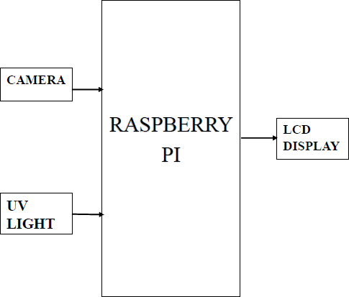
Fig. 1. Hardware logic flow. A Raspberry Pi 4 orchestrates the verification process, capturing raw frames via the optical sensor and driving the Liquid Crystal Display (LCD) to signal the final authentication verdict.

- Hardware Design

A Raspberry Pi 4 Model B (4 GB RAM) [6] drives the system. We chose its Quad-core Cortex- A72 (ARM v8) 64-bit System on Chip (SoC) run- ning at 1.5 GHz [6] specifically to handle OpenCV

without the lag common in weaker microcontrol- lers. The optical front-end centers on a Raspberry Pi Camera Module V2 (Sony IMX219 sensor), linked via the high-throughput Camera Serial Inter- face (CSI) bus [7]. We mount this sensor inside a custom-fabricated Optical Isolation Chamber (Dark Box) to block external light interference. Inside, a 365 nm UV source strikes the surface at a 45- degree incidence angle; this geometry maximizes the fluorescence of security fibers while deflecting specular reflection away from the lens. Feedback reaches the user via a 16x2 Liquid Crystal Display (LCD). We attached an I2C backpack to the unit, simplifying the GPIO interface to just two data lines (SDA/SCL) [8] (see Fig. 2).
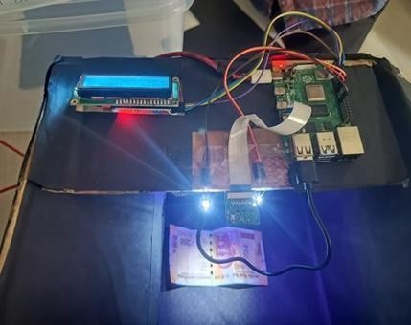

Fig. 2. Operational validation rig executing a live scan on a
₹200 banknote. The layout exposes the Raspberry Pi 4 control- ler, I2C diagnostic LCD, suspended CSI camera module, and active LED illuminators over the optical darkroom.

- Software Stack

The prototype boots a lightweight Linux kernel (Raspberry Pi OS). We wrote the core logic in Py- thon 3, calling OpenCV 4.5 for vision tasks and RPi.GPIO for hardware signaling. Crucially, we threaded the Image Acquisition loop separately from the Processing loop. This prevents the user interface from freezing during the heavy feature- matching cycles.

- METHODOLOGY

Our verification logic fuses spectral data (col- or) with spatial geometry. We operate on the prem- ise that high-quality photocopies may pass visual pattern tests but will fail spectral analysis due to missing fluorescent ink. Conversely, genuine notes that are soiled might fail pattern matching but will still fluoresce. Consequently, a note is deemed au- thentic only if it clears both validation checks con- currently.
- Image Pre-processing
These operations execute the moment the cam- era captures a frame to condition the raw data for the embedded ARM processor. The subsampling stage shrinks the 8-megapixel input to prevent memory bottlenecks and reduce computational latency. The Gaussian convolution then acts as a low-pass filter, stripping away high-frequency sen- sor grain caused by the low-light UV isolation chamber. This dual-stage stabilization ensures the pixel matrix is mathematically clean before it en- ters the ORB spatial search and HSV color grading pipelines. The system captures a raw frame I raw at the native sensor resolution (3280 x 2464). Subsampling:
𝐼 𝑝𝑟𝑜𝑐 = 𝑅𝑒𝑠𝑖𝑧𝑒(𝐼 𝑟𝑎𝑤, 𝜆) (1)

Where:

  - I proc Output buffer.
  - I raw: Input frame.
  - λ: Compression factor (0.6).

Gaussian Blur:

𝐼 𝑠𝑚𝑜𝑜𝑡ℎ = 𝐼 𝑝𝑟𝑜𝑐 ∗ 𝐺𝜎 (2)

Where:

  - Ismooth: Filtered matrix.
  - Gσ: Weighting kernel.

  - * : Discrete convolution.

- Spectral Analysis (Fluorescence Quantification)

This spectral gating step runs directly after the image stabilization phase. To isolate the exact cy- an-blue emission of genuine security fibers under 365nm UV light, the thresholding algorithm con- verts the frame into the HSV color space. A strict luminance filter then strips out any ambient back- ground interference. Adding up the surviving high- intensity pixels produces the total fluorescence score. Standard bleached paper drops out at this stage because it misses the required optical bright- eners entirely.

𝑀(𝑥, 𝑦) = 1, 𝑖𝑓 𝐻(𝑥, 𝑦)𝑖𝑛 [𝑇 𝑙𝑜𝑤, 𝑇 ℎ𝑖𝑔ℎ]
𝑀(𝑥, 𝑦) = 0, 𝑜𝑡ℎ𝑒𝑟𝑤𝑖𝑠𝑒 (3)

Where:

  - M(x,y): Binary segmentation matrix.

  - H(x,y): Hue channel.
  - [T low, T high]: Chromatic passband (80– 140).

Photometric Gating:
High-pass intensity filter (V > 200):
𝑆 𝑓𝑙𝑢𝑜 = Ʃ(𝑀(𝑥, 𝑦) && 𝑉𝑚𝑎𝑠𝑘(𝑥, 𝑦)) (4)

Where:

  - S fluo Valid pixel sum.
  - Vmask isolates high-brightness regions.
  - && is the logical conjunction.

If the score S fluo falls below the threshold Tuv (fixed at 5000 pixels), the note is immediately flagged as counterfeit.

- Spatial Pattern Verification (ORB):

Validating structural details—specifically mi- cro-printing, bleed lines, and the Gandhi portrait— demands robust spatial analysis. We therefore de- ploy ORB (Oriented FAST and Rotated BRIEF) [3]. Unlike [2], which tracks random fibers and needs a database of every printed note, ORB veri- fies the Deterministic Class Features of the denom- ination. We chose ORB over SIFT or SURF be- cause its binary descriptors are computationally lighter, enabling the ARM processor to match fea- tures without lag.

- Feature Extraction:
Interest points are harvested via the Fea- tures from Accelerated Segment Test (FAST). The routine validates a candidate p by inspecting its 16-pixel perimeter for a continuous sequence of contrasting inten- sities.
- Orientation Assignment: To compensate for arbitrary input rotation, we derive the intensity centroid C for the patch. This vector establishes the principal angle θ :

𝜃 = 𝑎𝑡𝑎𝑛2(𝑚01, 𝑚10) (5)

Where:

  - θ Polar heading.
  - m01, m10 Linear intensity mo- ments.
- Descriptor Generation:
We build the binary descriptor d using Bi- nary Robust Independent Elementary Fea- tures (BRIEF). Crucially, the algorithm steers the pixel-pair comparison pattern to align with theta.

- Matching and Validation

We cross-reference the live feature set (D live) against a stored "Golden Template" (Dref) using a Brute-Force Matcher. We compare binary ORB descriptors using the Hamming distance (H dist). The function tallies the bitwise differences via a population count:
𝐻 𝑑𝑖𝑠𝑡(𝑑1, 𝑑2) = 𝑝𝑜𝑝𝑐𝑜𝑢𝑛𝑡(𝑑1 ˄ 𝑑2) (6)

Where:

  - H dist The count of mismatched bits.
  - d1, d2 Binary vectors.
  - ˄ is the bitwise exclusive OR.

We prune ambiguous matches using Lowe’s Ratio Test [5].
Ratio Test: Ambiguity rejection via Lowe's ratio. The nearest neighbor d1 is retained if it is distinct from the second-nearest neighbor d2.

𝐻 𝑑𝑖𝑠𝑡(𝑑1) < 0.75 ∗ 𝐻 𝑑𝑖𝑠𝑡(𝑑2) (7)

Where:

  - 0.75 Discrimination ratio.

Final Decision Logic: Authentication requires the simultaneous assertion of both validity flags. A banknote is labeled GENUINE only if the valid pattern count (Nvalid) clears the pattern threshold (Tmatch) AND the fluorescence score surpasses the UV threshold (Tuv) [9].

Result =

(𝑁𝑣𝑎𝑙𝑖𝑑 > 𝑇𝑚𝑎𝑡𝑐ℎ) && (𝑆 𝑓𝑙𝑢𝑜 > 𝑇𝑢𝑣) (8)

Where:

  - Nvalid The count of qualified matches.
  - Tmatch The correspondence lower bound (30).
  - Tuv Fluorescence intensity threshold (5000).

- IMPLEMENTATION

The prototype functions on Raspberry Pi OS (Legacy Buster) using Python 3.7. Computer vision tasks utilize the Open Source Computer Vision Library (OpenCV) v4.5.1, employing the C++ backend for ARM architecture optimization [4].
- Initialization Protocol

Boot latency is reduced via a serialized startup sequence. Descriptor Serialization loads "Golden Templates" as pre-computed NumPy arrays (.npy) instead of raw images. This decreases cold-start duration (T boot) by approximately 40 percent and restricts Random Access Memory (RAM) usage to under 150 MB [10]. Sensor Stabilization mandates a camera warm-up period (Twarm = 2.0s) for Au- tomatic Gain Control (AGC) and Auto-White Bal- ance (AWB) convergence under monochromatic UV lighting [11].

- Multi-threaded Architecture

The software isolates raw camera I/O from the vision mathematics via a Producer-Consumer threading scheme.

  - Thread A (Acquisition): Calls picam2 cap- ture_array() without adding any delays. The background script pushes the raw camera matrices straight into a 3-deep ring buffer.
  - Thread B (Analysis): Grabs the newest pixel matrix off the ring. It then forces that data straight through the hybrid verifica- tion pipeline. By splitting these tasks, the intensive CPU feature matching never bot- tlenecks the native camera frame rate [12].

- Display Logic (FSM)

Pushing text straight to the Liquid Crystal Dis- play (LCD) loop creates severe visual flicker. We eliminate this display tearing by driving the screen through a three-stage Finite State Machine (FSM).

  - State S0 (Idle): Runs when the optical chamber sits empty, confirmed by a near- zero UV baseline (S fluo ~0).
  - State S1 (Processing): Takes over the in- stant the camera catches a valid Region of Interest (ROI) and starts the ORB de- scriptor search.
The hardware forces a strict delay (T hold = 2.0s) inside S2 before reverting to S0.

- EXPERIMENTAL SETUP

To strictly validate the proposed system against the theoretical benchmarks established in
[2] and [13], a comprehensive experimental dataset was constructed. This setup was designed to simu- late the harsh, variable conditions typical of the Indian retail environment.

- Dataset Generation (The Golden Templates)

A "Golden Template" is defined as a high- fidelity reference image of a pristine, genuine banknote. Trials employed INR denominations:
₹100, ₹200, ₹500. The reference database (Dref) indexes four spatial variants per class for affine invariance (see Fig. 3).
  - Template A (Obverse-Numeral): Targets denomination value (Optically Variable Ink/OVI).
  - Template B (Obverse-Portrait): Isolates Mahatma Gandhi portrait; electrotype wa- termark.
  - Template C (Reverse-Panel): Targets lan- guage panel and motif.
  - Template D (Full UV Map): Long- exposure capture (365nm) mapping static fluorescent ink patterns.
These images constitute the Ground Truth for the Oriented FAST and Rotated BRIEF (ORB) feature matcher.
- Experimental Validation Protocol:

System evaluation involved a cumulative stress test of N = 200 trials. Samples were seg- mented into four classes for failure mode analysis:
  - Category 1 (Genuine-Mint) : Uncirculated notes from banking institutions establish- ing the True Positive baseline.
  - Category 2 (Genuine-Soiled) :
General circulation banknotes exhibiting mechanical wear (folds, lipid accretion, tears). Benchmarks Oriented FAST and Rotated BRIEF (ORB) feature persistence against visual noise [14].

  - State S2 (Result Lock): Holds the final Genuine or Counterfeit decision on the display.

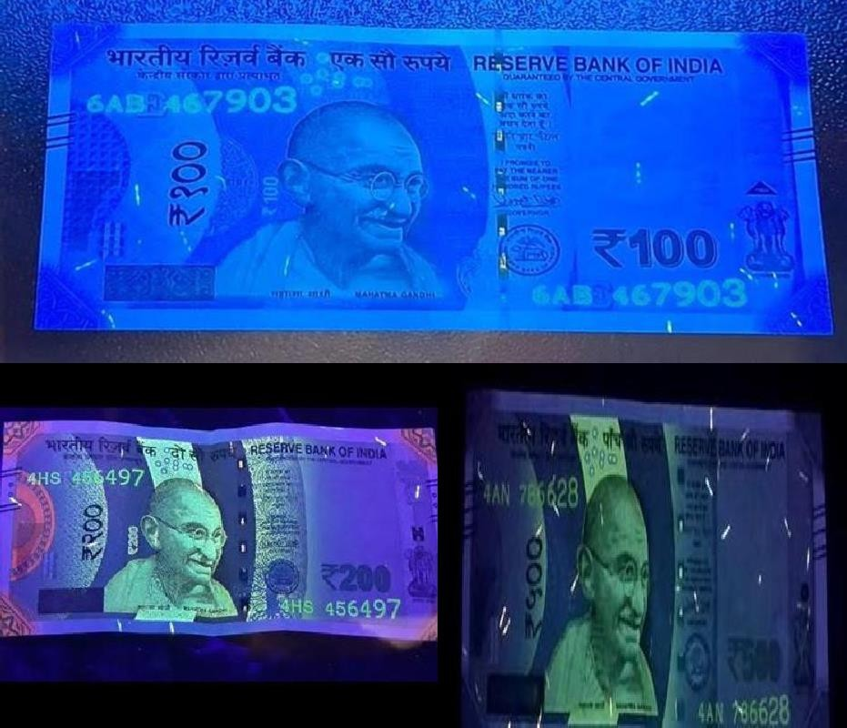

Fig. 3. The "Golden Template" reference dataset. ₹100 Note, ₹200 Note, ₹500 Note. These images serve as the ground truth for spectral and spatial verification.

  - Category 3 (Counterfeit-Photocopy): High-resolution (1200dpi) color photocop- ies on 80 GSM bond paper, testing detec- tion of absent micro-printing and intaglio texture.
  - Category 4 (Counterfeit-Bleached): Bleached and reprinted genuine currency paper (lower to higher denomination). This adversarial attack tests UV analysis spectral resolution [15].
- Threshold Tuning and Calibration

The decision thresholds for Pattern Match Count (Tmatch) and Fluorescence Score (Tuv) were not arbitrary but derived empirically from the statistical distribution of the training data.
- UV Threshold Calibration:
Category 3 (Photocopy) evaluation quanti- fied a peak background luminance (S fluo) of 450. This low score is due to the lack of specialized UV ink, despite the presence of optical brightening agents in standard
paper. In contrast, Category 1 (Mint) notes consistently yielded mean scores u > 8000. A 6sigma statistical guard band de- fined the threshold Tuv = 5000 [9].
- Match Density: Authentic samples re- turned a valid inlier count (N valid) of 60–
150. Mechanical degradation (Category 2) reduced descriptor density to 35–50. Ad- versarial inputs, lacking Intaglio micro- texture, saturated at <12 matches. Consequently, the pattern threshold was set to Tmatch = 30 to accommodate worn currency while maintaining a strict rejec- tion boundary for fakes [16] (see Fig. 4).
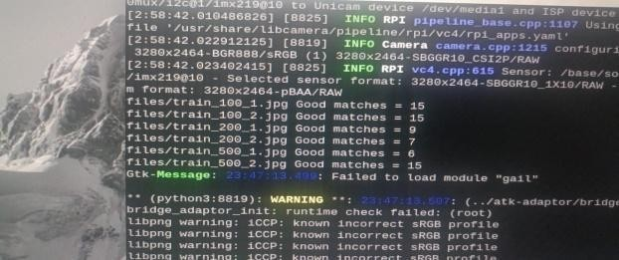
Fig. 4. Console Output. Validates ₹500 feature lock (N valid = 15) segregates target from invalid denominations.

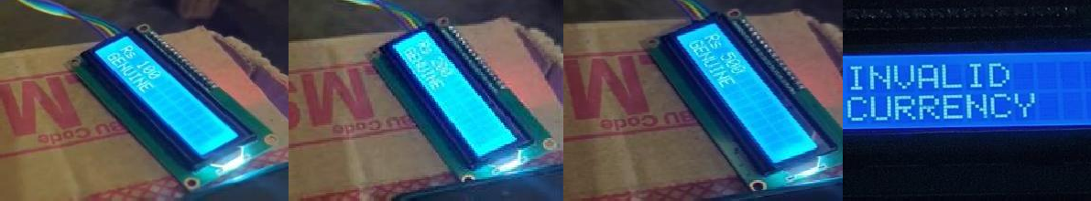
(a) (b) (c) (d) Fig. 5. LCD Terminal Output. (a) ₹100 Verified. (b) ₹200 Verified. (c) ₹500 Verified. (d) Counterfeit Rejection ("INVALID").

- RESULTS

Evaluation covered Accuracy, Latency, False Acceptance Rate (FAR), and False Rejection Rate (FRR). Testing used the Section VI dataset (N=200) with ₹100, ₹200, and ₹500 denominations.

- Classification Accuracy
Cumulative precision: 96.5%. Confusion matrix analysis segregates detection variance by substrate quality (see Table I and Fig. 5).

  - Genuine Notes: Mint notes (N=50) showed 100% True Positive Rate (TPR). The soiled batch (N=50) had an 8% False Rejection Rate (FRR) (N=4). Severe folds in the Mahatma Gandhi Region of Interest (ROI) reduced ORB keypoints below the threshold (N valid < 30).
  - Counterfeit Samples: "Photocopy" and "Bleached" variants failed every test. Premium fakes bypassed coordinate logic (T match) then failed spectral floors (S fluo < 5000) lacking embedded phosphors. TABLE I.

TABLE I.
SYSTEM PERFORMANCE METRICS

Category | Total | Detected Genuine | Detected Fake | Accuracy%
Genuine  (Mint) | 50 | 50 | 0 | 100
Genuine (Soiled) | 50 | 46 | 4 | 92
Fake (Xerox) | 50 | 0 | 50 | 100

- Computational Latency:
Average processing time (T proc) on Raspberry Pi 4 (Hybrid Algorithm): 4.8s.

- Acquisition: 0.8 s
- Preprocessing (Resize/Gaussian): 0.5 s
- ORB Feature Matching: 3.5 s
- Spectral Analysis: 0.2 s
This latency is acceptable for retail point-of- sale scenarios, where the priority is the high- fidelity verification of high-value notes (₹500) ra- ther than high-speed counting [12]. The system trades speed for accuracy, performing a deep spa- tial search (N features = 2000) to minimize false negatives.
- DISCUSSION

Ferrero and Montrucchio [2] target specific notes via Fiber ID. This method checks class fea- tures (Pattern + Fluorescence).

  - Deterministic vs. Stochastic Verification: [2] tracks random fiber distribution, requiring a database of every circulating note. System ver- ification uses static Reserve Bank of India (RBI) UV ink patterns. Local storage requires only 5MB for Golden Templates, enabling of- fline operation without network access [16].

  - Robustness to Mimicry: A major concern in banknote authentication is "mimicking," where counterfeiters replicate security features. While the forensic method is mathematically immune to mimicking, our system effectively counters it through Multi-Modal Validation. A counter- feiter would need to replicate both the visual micro-print (to pass ORB) and the chemical fluorescence (to pass UV) simultaneously. Production costs for high-quality fakes exceed the face value of low denominations (₹100,
₹200) [17].

Table II evaluates this hybrid framework against existing academic literature. Forensic tracking [2] yields flawless validation yet demands continuous cloud queries via heavy optics. Pure software mod- els [13], [14] running on normal computers fail against bleached fakes entirely since they drop UV isolation.

TABLE II.
COMPARISON OF RECENT AUTHENTICATION FRAME- WORKS

Refer- ence | Hard-  ware Platform | Core  Methodol- ogy | Execution  Architec- ture | Primary  Limitation / Advantage
Ferrero [2] | High-Res Scanner | Stochastic Fiber Hash | Cloud / Database | Requires synchro- nized global  ledger
Kim [13] | Desktop PC | HSV +  Neural Networks | Local / Offline | High ther- mal and computa-  tional load
Sharma [14] | Standard PC | ORB Fea-  ture Match- ing | Local / Offline | Vulnerable to bleached  OBA paper fakes
Proposed | Raspber- ry Pi 4 | Hybrid (HSV + ORB) | Edge / Offline | Hardware- resilient to bleaching (96.5%)

- G. Bradski, "The OpenCV library," Dr. Dobb's J. Softw. Tools, vol. 25, pp. 120-125, 2000.

- D. G. Lowe, "Distinctive image features from scale-invariant keypoints," Int. J. Comput. Vis., vol. 60, no. 2, pp. 91–110, Nov. 2004.

- Raspberry Pi Ltd, "Raspberry Pi 4 Model B datasheet," 2023. [Online]. Available: https://datasheets.raspberrypi.com/rpi4/raspberry-pi-4- datasheet.pdf

- Sony Semiconductor Solutions, "IMX219PQ CMOS image sensor product brief," 2020. [Online]. Available: https://www.sony-semicon.co.jp/e/products/IS/sensor2/

- Broadcom Corporation, "BCM2711 ARM peripheral manu- al," 2020. [Online]. Available: https://datasheets.raspberrypi.com/bcm2711/bcm2711- peripherals.pdf

- CONCLUSION AND FUTURE SCOPE

Standalone embedded system for Indian cur- rency authentication. Combining UV spectral data and ORB feature matching fills the technical gap between banking sorters and manual UV lamps. Offline architecture maintains reliability in net- work-dead zones.

Upcoming Roadmap:

  - MobileNetV2 Migration: Drop ORB fa- voring an embedded CNN. Goal: Reliabil- ity against mutilated bills when hardcoded features break [18].

  - IR Integration: Wire Infrared (IR) sensors spotting IR-absorbing ink formulations. Outcome: Triple-tier shielding (Visible, UV, IR) [19].
  - Chain Logging: Push counterfeit serial numbers onto an internal blockchain. That distributed ledger tracks localized scams spanning disconnected retail terminals [20].

REFERENCES

- Reserve Bank of India, "Annual Report 2023-24: Currency Management," Mumbai, 2024. [Online]. Available: https://www.rbi.org.in/Scripts/AnnualReportPublications.aspx

- R. Ferrero and B. Montrucchio, "Banknote identification through unique fluorescent properties," IEEE Sensors J., vol. 11, no. 1, pp. 1-10, Jan. 2011.

- E. Rublee, V. Rabaud, K. Konolige, and G. Bradski, "ORB: An efficient alternative to SIFT or SURF," in Proc. IEEE Int. Conf. Comput. Vis. (ICCV), 2011, pp. 2564–2571.
- N. Otsu, "A threshold selection method from gray-level histograms," IEEE Trans. Syst., Man, Cybern., vol. 9, no. 1, pp. 62-66, Jan. 1979.

- G. Van Rossum and F. L. Drake, Python 3 Reference Man- ual, Scotts Valley, CA: CreateSpace, 2009.

- Z. Zhang, "A flexible new technique for camera calibra- tion," IEEE Trans. Pattern Anal. Mach. Intell., vol. 22, no. 11,
pp. 1330-1334, Nov. 2000.

- A. F. Otoom, H. A. Abdullah, and S. O. A. Al-Shorman, "Real-time recognition of Jordanian banknotes using SIFT algo- rithm," Int. J. Comput. Appl., vol. 101, no. 14, pp. 1-6, 2014.

- S. T. Kim, "Banknote recognition using HSV color space and neural network," J. Elect. Eng. Technol., vol. 12, no. 5, pp. 2021-2028, 2017.

- R. K. Sharma and M. S. Uddin, "Banknote recognition using ORB and brute-force matcher," J. King Saud Univ. - Comput. Inf. Sci., vol. 34, no. 8, pp. 5621-5630, 2022.

- V. V. Patil and R. J. Ramteke, "Indian paper currency recognition system using image processing," Int. J. Adv. Res. Comput. Sci., vol. 8, no. 5, pp. 120-124, 2017.

- T. A. Zia, "Ubiquitous computing for banknote recognition and visually impaired support," IEEE Trans. Consum. Electron., vol. 64, no. 3, pp. 345-353, Aug. 2018.

- A. Mittal and A. Sofat, "Automated counterfeit currency detection techniques: A review," Int. J. Comput. Sci. Inf. Tech- nol., vol. 6, no. 3, pp. 2883-2886, 2015.

- L. Li, X. Huang, and J. Feng, "Deep learning for fake cur- rency detection," IEEE Trans. Inf. Forensics Security, vol. 14, no. 8, pp. 2021-2035, Aug. 2019.

- P. D. Bhavani and K. Karthikeyan, "Fake currency detec- tion using image processing," in Proc. IEEE Int. Conf. Sig. Proc. Commun. (ICSPC), 2017, pp. 1-5.

- A. B. Centeno, S. van der Walt, and J. van Rooyen, "Identi- ty document and banknote security forensics: A survey," in Proc. IEEE Int. Workshop Inf. Forensics Security (WIFS), 2019,
pp. 1-6.

